The Economist

Free speech

Under attack

Curbs on free speech are growing tighter. It is time to speak out?

Jun 4th 2016 | From the print edition

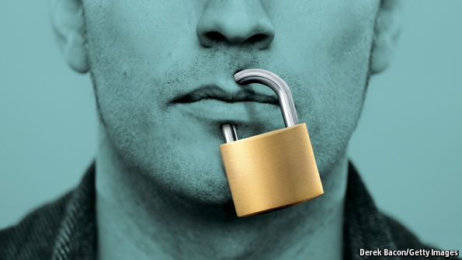
IN a sense, this is a golden age for free speech. Your smartphone can call up newspapers from the other side of world in seconds. More than a billion tweets, Facebook posts and blog updates are published every single day. Anyone with access to the internet can be a publisher, and anyone who can reach Wikipedia enters a digital haven where America’s First Amendment reigns.
However, watchdogs report that speaking out is becoming more dangerous—and they are right. As our report shows, curbs on free speech have grown tighter. Without the contest of ideas, the world is timid and ignorant.

Free speech is under attack in three ways. First, repression by governments has increased. Several countries have reimposed cold-war controls or introduced new ones. After the collapse of the Soviet Union, Russia enjoyed a free-for-all of vigorous debate. Under Vladimir Putin, the muzzle has tightened again. All the main television-news outlets are now controlled by the state or by Mr Putin’s cronies. Journalists who ask awkward questions are no longer likely to be sent to labour camps, but several have been murdered.
China’s leader, Xi Jinping, ordered a crackdown after he took over in 2012, toughening up censorship of social media, arresting hundreds of dissidents and replacing liberal debate in universities with extra Marxism. In the Middle East the overthrow of despots during the Arab spring let people speak freely for the first time in generations. This has lasted in Tunisia, but Syria and Libya are more dangerous for journalists than they were before the uprisings; and Egypt is ruled by a man who says, with a straight face: “Don’t listen to anyone but me.”
Words, sticks and stones
Second, a worrying number of non-state actors are enforcing censorship by assassination. Reporters in Mexico who investigate crime or corruption are often murdered, and sometimes tortured first. Jihadists slaughter those they think have insulted their faith. When authors and artists say anything that might be deemed disrespectful of Islam, they take risks. Secular bloggers in Bangladesh are hacked to death in the street (see article); French cartoonists are gunned down in their offices. The jihadists hurt Muslims more than any others, not least by making it harder for them to have an honest discussion about how to organise their societies.
Third, the idea has spread that people and groups have a right not to be offended. This may sound innocuous. Politeness is a virtue, after all. But if I have a right not to be offended, that means someone must police what you say about me, or about the things I hold dear, such as my ethnic group, religion, or even political beliefs. Since offence is subjective, the power to police it is both vast and arbitrary.
Nevertheless, many students in America and Europe believe that someone should exercise it. Some retreat into the absolutism of identity politics, arguing that men have no right to speak about feminism nor whites to speak about slavery. Others have blocked thoughtful, well-known speakers, such as Condoleezza Rice and Ayaan Hirsi Ali, from being heard on campus (see article).
Concern for the victims of discrimination is laudable. And student protest is often, in itself, an act of free speech. But university is a place where students are supposed to learn how to think. That mission is impossible if uncomfortable ideas are off-limits. And protest can easily stray into preciousness: the University of California, for example, suggests that it is a racist “micro-aggression” to say that “America is a land of opportunity”, because it could be taken to imply that those who do not succeed have only themselves to blame.
The inconvenient truth
Intolerance among Western liberals also has wholly unintended consequences. Even despots know that locking up mouthy but non-violent dissidents is disreputable. Nearly all countries have laws that protect freedom of speech. So authoritarians are always looking out for respectable-sounding excuses to trample on it. National security is one. Russia recently sentenced Vadim Tyumentsev, a blogger, to five years in prison for promoting “extremism”, after he criticised Russian policy in Ukraine. “Hate speech” is another. China locks up campaigners for Tibetan independence for “inciting ethnic hatred”; Saudi Arabia flogs blasphemers; Indians can be jailed for up to three years for promoting disharmony “on grounds of religion, race...caste...or any other ground whatsoever”.
The threat to free speech on Western campuses is very different from that faced by atheists in Afghanistan or democrats in China. But when progressive thinkers agree that offensive words should be censored, it helps authoritarian regimes to justify their own much harsher restrictions and intolerant religious groups their violence. When human-rights campaigners object to what is happening under oppressive regimes, despots can point out that liberal democracies such as France and Spain also criminalise those who “glorify” or “defend” terrorism, and that many Western countries make it a crime to insult a religion or to incite racial hatred.
One strongman who has enjoyed tweaking the West for hypocrisy is Recep Tayyip Erdogan, president of Turkey. At home, he will tolerate no insults to his person, faith or policies. Abroad, he demands the same courtesy—and in Germany he has found it. In March a German comedian recited a satirical poem about him “shagging goats and oppressing minorities” (only the more serious charge is true). Mr Erdogan invoked an old, neglected German law against insulting foreign heads of state. Amazingly, Angela Merkel, the German chancellor, has let the prosecution proceed. Even more amazingly, nine other European countries still have similar laws, and 13 bar insults against their own head of state.
Opinion polls reveal that in many countries support for free speech is lukewarm and conditional. If words are upsetting, people would rather the government or some other authority made the speaker shut up. A group of Islamic countries are lobbying to make insulting religion a crime under international law. They have every reason to expect that they will succeed.
So it is worth spelling out why free expression is the bedrock of all liberties. Free speech is the best defence against bad government. Politicians who err (that is, all of them) should be subjected to unfettered criticism. Those who hear it may respond to it; those who silence it may never find out how their policies misfired. As Amartya Sen, a Nobel laureate, has pointed out, no democracy with a free press ever endured famine.
In all areas of life, free debate sorts good ideas from bad ones. Science cannot develop unless old certainties are queried. Taboos are the enemy of understanding. When China’s government orders economists to offer optimistic forecasts, it guarantees that its own policymaking will be ill-informed. When American social-science faculties hire only left-wing professors, their research deserves to be taken less seriously.
The law should recognise the right to free speech as nearly absolute. Exceptions should be rare. Child pornography should be banned, since its production involves harm to children. States need to keep some things secret: free speech does not mean the right to publish nuclear launch codes. But in most areas where campaigners are calling for enforced civility (or worse, deference) they should be resisted.
Blasphemy laws are an anachronism. A religion should be open to debate. Laws against hate speech are unworkably subjective and widely abused. Banning words or arguments which one group finds offensive does not lead to social harmony. On the contrary, it gives everyone an incentive to take offence—a fact that opportunistic politicians with ethnic-based support are quick to exploit.
Incitement to violence should be banned. However, it should be narrowly defined as instances when the speaker intends to goad those who agree with him to commit violence, and when his words are likely to have an immediate effect. Shouting “Let’s kill the Jews” to an angry mob outside a synagogue qualifies. Drunkenly posting “I wish all the Jews were dead” on an obscure Facebook page probably does not. Saying something offensive about a group whose members then start a riot certainly does not count. They should have responded with words, or by ignoring the fool who insulted them.
In volatile countries, such as Rwanda and Burundi, words that incite violence will differ from those that would do so in a stable democracy. But the principles remain the same. The police should deal with serious and imminent threats, not arrest every bigot with a laptop or a megaphone. (The governments of Rwanda and Burundi, alas, show no such restraint.)
Areopagitica online
Facebook, Twitter and other digital giants should, as private organisations, be free to decide what they allow to be published on their platforms. By the same logic, a private university should be free, as far as the law is concerned, to enforce a speech code on its students. If you don’t like a Christian college’s rules against swearing, pornography and expressing disbelief in God, you can go somewhere else. However, any public college, and any college that aspires to help students grow intellectually, should aim to expose them to challenging ideas. The world outside campus will often offend them; they must learn to fight back using peaceful protests, rhetoric and reason.
These are good rules for everyone. Never try to silence views with which you disagree. Answer objectionable speech with more speech. Win the argument without resorting to force. And grow a tougher hide.

Campus protests and free speech

The colliding of the American mind

University protesters believe they are fighting for justice; their critics think free speech is imperiled

Jun 4th 2016 | PRINCETON AND YALE | From the print edition

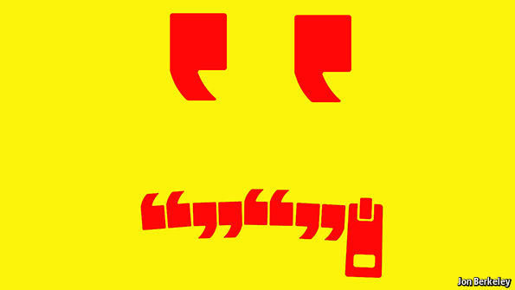

VISITING some American universities these days feels like touring the scene of an earthquake, or a small war. Though administrators insist the protests that dominoed across campuses in the past year were therapeutic, grievances seethe. Fears for jobs, and of harm—both reputational and physical—endure. “The campus is traumatised,” says Reuben Faloughi, one of the leaders of the protests which, last November, forced the University of Missouri’s president to resign.
As Mr Faloughi knows, some external observers “just think the kids got upset and had a fit”: that these disturbances conform to the old quip about academic quarrels being so vicious because the stakes are so low. That view is mistaken, and not only because of the impact on the participants. As Eshe Sherley, an activist at Yale, says, “Things that happen in the university don’t just stay there.” Rather, the people and ideas they produce ripple across the country. And just as the energy and issues involved are bound to spread beyond campus, they did not originate there either.
The protesters believe they are pursuing social and racial justice, in part by changing the way America remembers its past—debates that are convulsing the country at large. For others the right at stake is freedom of speech, a principle imperilled around the world. As Nicholas Christakis, a Yale professor caught up in the turmoil, puts it: “If we can’t get that right at our elite universities, we’re doomed.” How far these values are compatible, and whether their advocates can listen to each other, are quandaries these events have dramatised.
The students are revolting
New-wave feminists and sexuality campaigners have added to the ruckus. So too have supporters and opponents of Israel, in a row that typifies how protecting one group’s rights can allegedly impinge on another’s. The Amcha Initiative, for example, aims to combat anti-Semitism at American universities, a job Tammi Rossman-Benjamin, its director, thinks the authorities are often unwilling to do. She wants them to decry prejudice against Jews as they would other forms of bigotry. Yet the initiative has been accused of stifling free expression. Official disapproval of the kind she seeks is, for some, tantamount to censorship; in the overlap between criticism of Israel and anti-Semitism, the line between legitimate and hateful opinion is contested.
Still, the main grievance racking American campuses is alleged racism. Several student groups demand more pluralistic curriculums, cultural-awareness training for staff, more diverse faculties and extra facilities for minorities. The flashpoints have sometimes been ugly. At Yale, after Erika Christakis, who is Dr Christakis’s wife and was then a residential college’s associate master, suggested in an e-mail that students might be allowed to pick and police their own Halloween costumes, the couple were cruelly harassed. In Missouri student protesters barracked and obstructed journalists; some professors lent a hand. Demonstrators at Princeton occupied the office of its president, Christopher Eisgruber. “They took quite good care of it,” he says, adding that threats to the students led the university to consult the FBI.
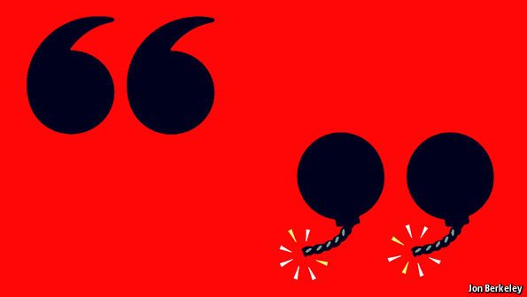
Some of these tactics are thuggish; thuggery, moreover, committed over seemingly piffling complaints. For instance, with its hammocks strung between blossoming trees, the courtyard of Yale’s Silliman College—where students claiming to feel endangered jeered Dr Christakis—is idyllic, despite its proximity to gritty bits of New Haven. Taken in isolation, these incidents can seem the lamentable fruit of modernity’s least appetising traits: mollycoddling parenting, a sub-Freudian narcissism, a hypochondriacal sense of entitlement and a social-media ecosystem that reinforces insularity and cultivates an expectation of instant response. As Mr Eisgruber says, recent demands “often involve an expectation of immediacy” that a slow college bureaucracy is ill-equipped to satisfy.
Those YouTube highlights, however, are a caricature. Clumsy and excitable as these demonstrations have sometimes been, dismissing them all as trivial is lazy. Peter Salovey, Yale’s president, notes that within a week of the Halloween kerfuffle, students were discussing broader concerns. Belittling them all as “crybullies” or “snowflake” protesters (for their exquisite fragility) ignores the breadth of their outlook, which is generally more historical than parochial. This wave of student activism coincides with the Black Lives Matter phenomenon, and they evince a shared rage at racialised political rhetoric and police abuses, to which even Ivy League students, or their families, can be exposed.
“We feel unsafe here,” says Ms Sherley at Yale, “like we feel unsafe everywhere.” Last year, for example, a black student at Yale, who happened to be the son of a New York Times columnist, was detained at gunpoint outside the library. Even the gripe about Halloween costumes is tangentially related: the stereotypes they reinforce—of black people as gangsters, say—can contribute to real-world injustice, the students argue. They know that today’s biases do not match up to full-blown segregation. Still, as Brea Baker, head of the Yale chapter of the NAACP, a black lobby group, says, “Better doesn’t mean good.”

Woodrow must wobble
Students and their sympathisers think that free speech is sometimes invoked to deflect these claims; or, so Princeton’s Black Justice League maintains, as a “justification for the marginalisation of others”. Echoing debates over memorials across the nation, many students have demanded that the slavery-tainted names of college buildings be changed. Some Princetonians want the public-policy school to honour someone other than Woodrow Wilson, a president who was a segregationist, albeit an idealistic promoter of world peace. Some Yalies object to Calhoun College commemorating a pro-slavery ideologue and statesman.
These requests are regarded by others as efforts to sanitise history. Announcing its recent decision to retain Calhoun’s name, Yale said that doing so would serve as a teaching aid. Princeton, too, has chosen to keep Wilson’s name, though a dining-hall mural of him, smiling and holding a baseball, has been scrubbed out. Both made compensating offers of explicatory artwork and exhibitions, while Yale promised to name a new college after Pauli Murray, a civil-rights leader. Whatever the merits of these demands—stronger in the case of Calhoun—they are not an infringement of free speech but an exercise of it. After all, whom institutions choose to celebrate and how they depict the past are choices to be debated, not immutable facts.
For all that, free speech is hardly a red herring. One ominous turn lies in the claim made by some protesters for the supremacy of their subjective judgments. Ms Baker argues that black people know best when they are being racially demeaned in the same way that women can best distinguish between a compliment and harassment. That may often be true. White, middle-aged deans would be rash to secondguess the experiences of black youngsters.
The powerful riposte is that, to function, society relies on impartial adjudication of wrongs, especially in an era of multiculturalism, with its attendant frictions. Prejudice may indeed abound, but for officials to intervene it must be proven, not merely alleged. In any case, the idea that any group’s experience is inaccessible to others is not just pessimistic but anti-intellectual: history, anthropology, literature and many other fields of inquiry are premised on the faith that different sorts of people can, in fact, understand each other.
Next consider the swelling range of opinion deemed to fall outside civilised discourse. To be sure, some opinions do, and the boundary shifts with time. The trouble now, says Zach Wood, a student at Williams College in Massachusetts, is that many people want to banish views that remain widely held among their compatriots, believing that, on neuralgic topics such as homosexuality, “It’s all said and done.” He runs a campus group that hosts challenging speakers. “Silence does nothing,” he reasons. Two of its invitations—to Suzanne Venker, author of “The War on Men”, and John Derbyshire, a racist provocateur—have recently been rescinded: Ms Venker was disinvited under pressure from other students, Mr Derbyshire by the college’s leadership. Mr Wood has been insulted, ostracised and (he is black) told he has “sold out his race”. Other prominent figures deterred or blocked from addressing university audiences include Condoleezza Rice, a former secretary of state, Ayaan Hirsi Ali, a former Muslim, and Jason Riley, an African-American journalist who wrote a book called “Please Stop Helping Us: How Liberals Make It Harder For Blacks To Succeed”.
Activists are entitled to their protests. But when, as at Williams, they decry counter-arguments as tantamount to violence, they stray into censorship. On campuses across America not only have speakers been disinvited or shouted down for espousing assorted heresies (a practice known as “no-platforming” in Britain); administrators have also been urged to dismiss staff who, like the Christakises, are held to have transgressed. Dissenters, and those who simply worry about saying the wrong thing, are increasingly inclined to keep their mouths shut. Much to their bafflement, the targets are often themselves left-leaning.
This creeping intolerance chimes with the paternalism of “trigger warnings”, whereby students are alerted to potentially upsetting passages in novels or other texts, as if solidarity in suffering were not one of art’s chief purposes. Theoretically, if not yet in practice, trigger warnings may oust great literature in favour of socialist-realist tedium. Then there are “safe spaces”, dedicated sanctuaries in which minorities can recuperate. Sebastian Marotta, a student who is part of a Princeton free-speech group, reckons a movement avowedly committed to diversity may perversely result in “self-segregation based on beliefs and identity”. As Ms Christakis summarised in her ill-fated Halloween e-mail, others fear that, with the connivance of teachers and their overlords, America’s universities “have become places of censure and prohibition”.
At the heart of this dispute is the role of the university itself. Should it shield youngsters from the fraught world they will soon enter or, by exposing them to its affronts, prepare them for it? This has a corollary: whether a student is an adult, or an in-betweener needing special protection and privileges (such as the right to spend a lot of time in the library and getting drunk). All of the above, say diplomatic university bosses. Some students, though, seem to emphasise incubation over preparation; hence their requests for more reprimands and intrusion, for supposedly improving bans and rules. What really distinguishes them from their predecessors, say their critics, is not solipsism, impatience or a certainty that can slide from admirable passion into self-righteousness, but the expectation that all their problems should be magicked away. Whereas, as Dr Christakis says, universities “cannot readily deliver utopia, much as we might want to”.
The new activism thus illustrates what, beyond the groves of academe, may be America’s biggest political problem: opponents’ rising tendency to talk past each other, so that disagreement escalates into conflict. Nevertheless, beyond the viral clips, for those who care to notice there are signs this divide can partially be bridged.
The students’ new-fangled vocabulary, such as the perpetual admonition of “privilege” and “micro-aggressions”, often mystifies their elders. Yet buried within the jargon are old-fashioned values that the most conservative fogey could embrace. Cultural “re-education” sounds Maoist, but helping staff to cope with students from different backgrounds is common sense. Campus Jewish centres are well-established “safe spaces”, to which no one much objects; places where minorities are able to feel inconspicuous or comfortable are perfectly sound ideas, provided people do not spend all their time in them. If sparingly deployed, trigger warnings, too, can be benign. A gentle alert to the impending description of rape, for example, may be less liberal craziness than good manners.
In the aftermath of the nastiness towards journalists at the University of Missouri, Mr Faloughi and others distributed flyers around campus urging students to respect the media and the First Amendment. “We’re students, we don’t know everything,” Mr Faloughi acknowledges. Yet sometimes, when they identify injustices that society has blithely tolerated, or opportunities for progress it has missed, angry students can turn out to be right.

A youthful trend

Don’t be so offensive

Young westerners are less keen than their parents on free speech

Jun 4th 2016 | From the print edition

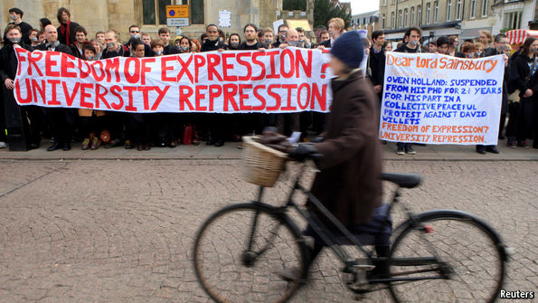

STRIDENCY on campus is not only an American problem. Throughout the West it is the young who are most ambivalent about free speech. A recent survey found that two-thirds of British students endorsed the National Union of Students’ “no-platform” policy. Speakers “no-platformed” in Britain include Peter Tatchell, a gay-rights activist who was a hero on campuses in the 1990s but has upset some of today’s students by favouring free speech even for homophobes.
Academics who think education requires the free flow of ideas are appalled. “A university is not a ‘safe space’,” tweeted Richard Dawkins, a biologist at Oxford. “If you need a safe space, leave, go home, hug your teddy & suck your thumb until ready for university.”
According to a survey last year by the Pew Research Centre, 47% of British 18- to 29-year-olds think the government should be able to stop people from saying things that offend other people’s religious beliefs, compared with 32% of those over 50. Fully 55% of French youngsters think that the government should intervene to prevent people from saying offensive things about minority groups, compared with 43% of their compatriots aged 30-49. In Germany 21% of 18- to 29-year-olds think the government should be able to stop the media from publishing information about large political protests, compared with only 9% of 30- to 49-year-olds. Young Americans are less likely to favour unfettered free speech than their elders are, but they are less censorious than young Europeans.
Overall, the global trend in academia is towards muzzling opinions deemed offensive. Students these days grow up “in a rough-and-tumble world on the internet”, notes another Oxford professor, “where abuse is universal”. Social-media sites such as Facebook and Twitter now make it possible to report offensive speech or images (this week they agreed to a code in Europe whereby they would block “illegal hate speech”). Years of clicking “report spam or abuse” may now have normalised the idea of silencing speech one disagrees with rather than debating it.

